City of Albuquerque
Employee Learning Center
1 Civic Plaza NW
Basement, City Hall
(T) 505-768-3200 (F) 505-768-3295
employeelearningcenter@cabq.gov
Registration forms must be submitted via email or fax.
Training Registration and Approval Form

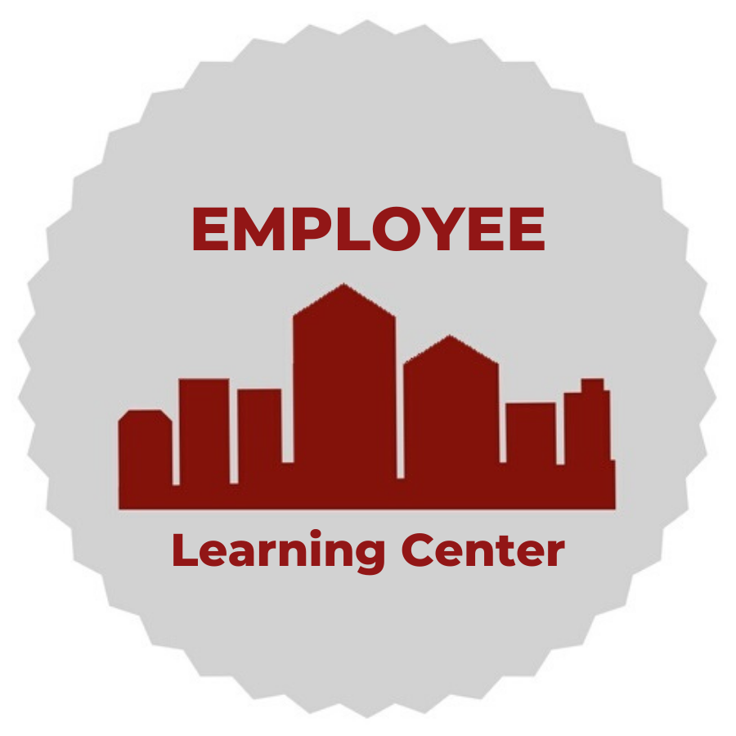

Program: Supervisor Development Program
Time: 8:00am – 5:00pm every Wednesday for 8 weeks
Location: Employee Learning Center, Basement of City Hall
Cost: $200 per participant
Session Dates (Please select one):
SDP 23-1 | SDP 23-2 | SDP 23-3 | SDP 23-4 | SDP 23-5
07/13/2022-  08/31/2022 | 09/14/2022-  11/02/2022 | 01/11/2023-  03/01/2023 | 03/08/2023-  04/26/2023 | 05/10/2023-  06/28/2023
Participant Information
Full Name: |  | Employee ID #:
Department: |  | Division:
Job Title: |  | Grade:
Work Phone: |  | Work Email:
Date of Hire: |  | Supervisor position start date:
Supervisor Information
Supervisor: | Supervisor’s Initials:
Work Email: |  | Work Phone:
Funding Source
Fund: |  | Account #:
Department #: |  | PC Bus. Unit:
PC Project: |  | PC Activity:
Source Type:

Requirements: The Director’s signature serves as approval for fees and attendance.
Director’s Name (Print) Director’s Signature Date

